Method and Results of nest count estimation

Tomo Eguchi

October 2020

# Results

## Data

Data for this analysis came from two leatherback nesting beaches in Indonesia (Jamursba-Medi and Wermon). Raw data for the analysis are the recorded number of nests per month.

### Jamursba-Medi

At Jamursba-Medi, some data have been collected since 1981. However, no data were collected in many years between the mid 1980s and late 1990s (Figure 1). A somewhat consistent effort starts in early 2000s and continue to recent years (Figure 1). The observed nest count in 1996 was 5058 and declined to less than 1000 since 2000.

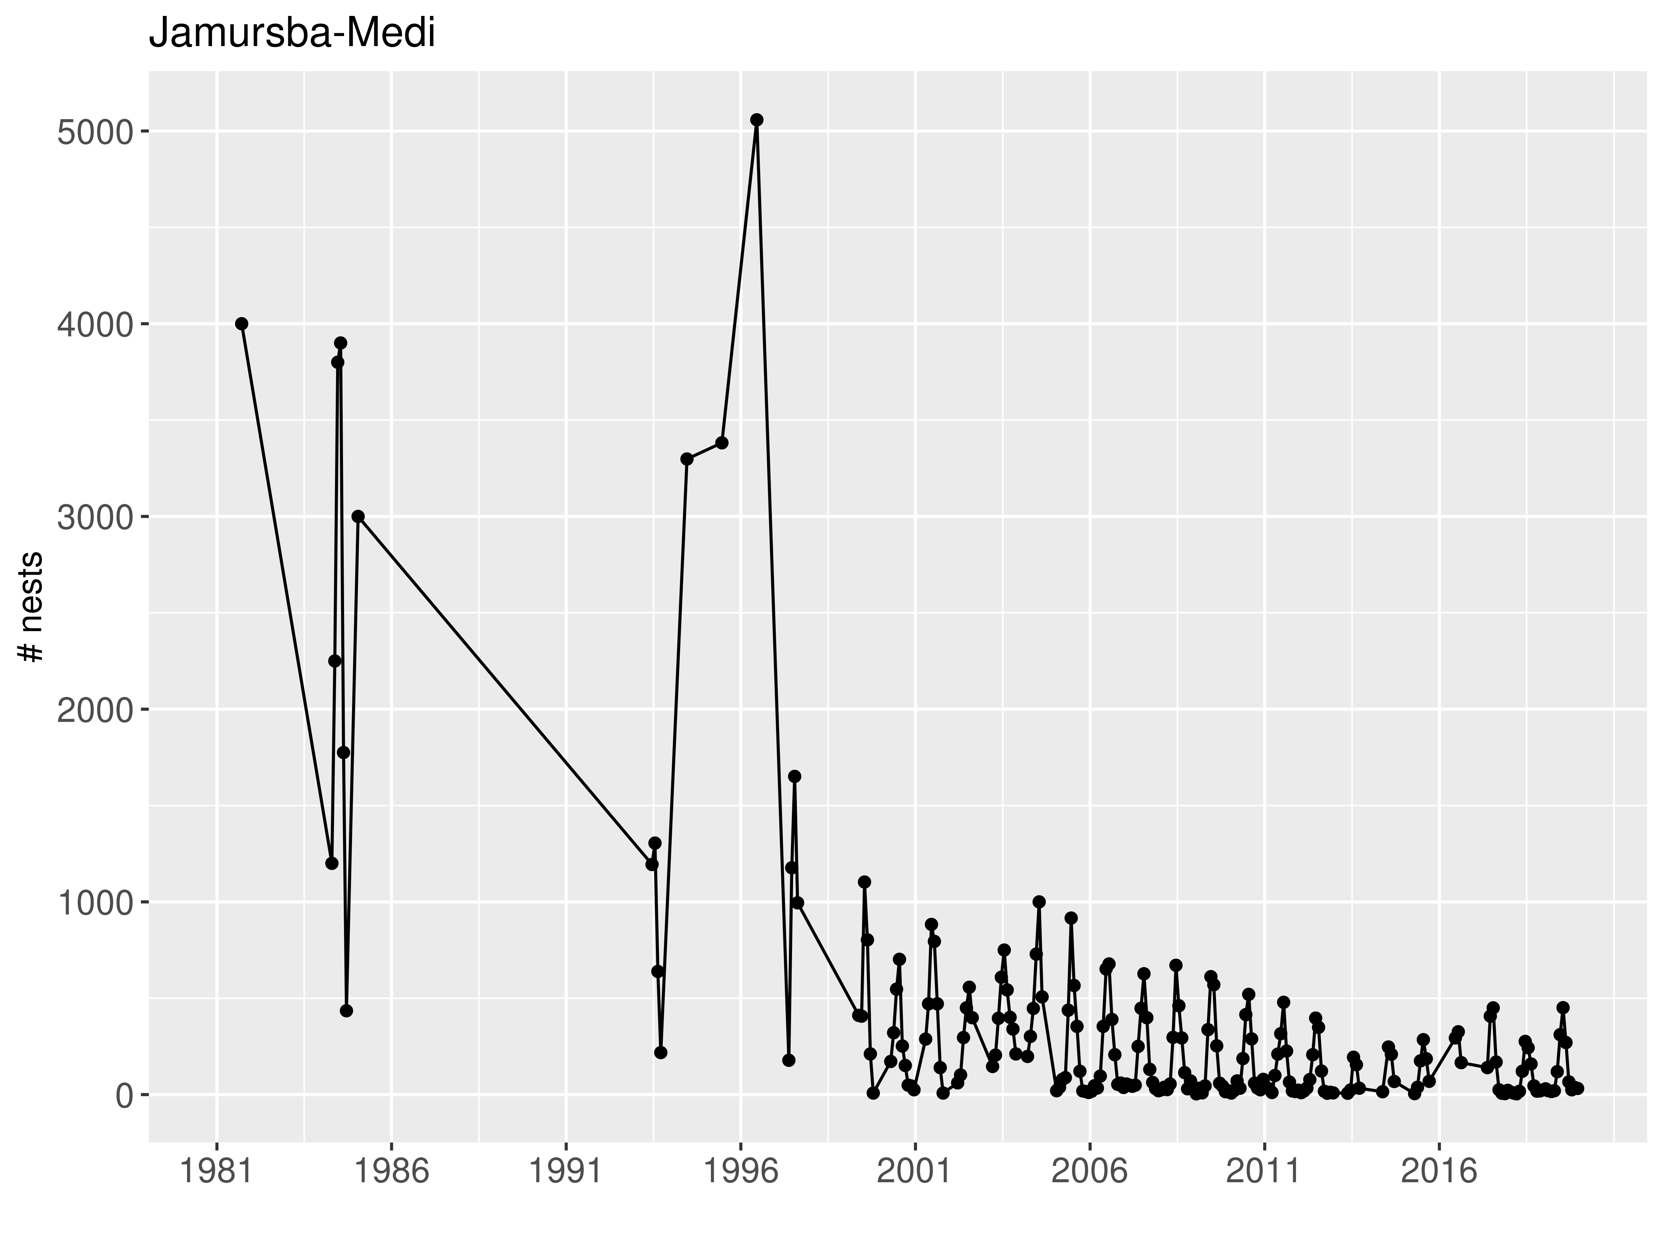

Figure 1. Nest counts at Jamursba-Medi

No data were collected in 1998. Since then at least some data were collected within each year. After analyzing datasets with different starting years, we found that starting at 1999 resulted in the longest dataset and good convergence of MCMC. Consequently, we decided to use data since 1999. The cyclical nature or seasonal fluctuations of counts is obvious in the raw counts (Figure 2).

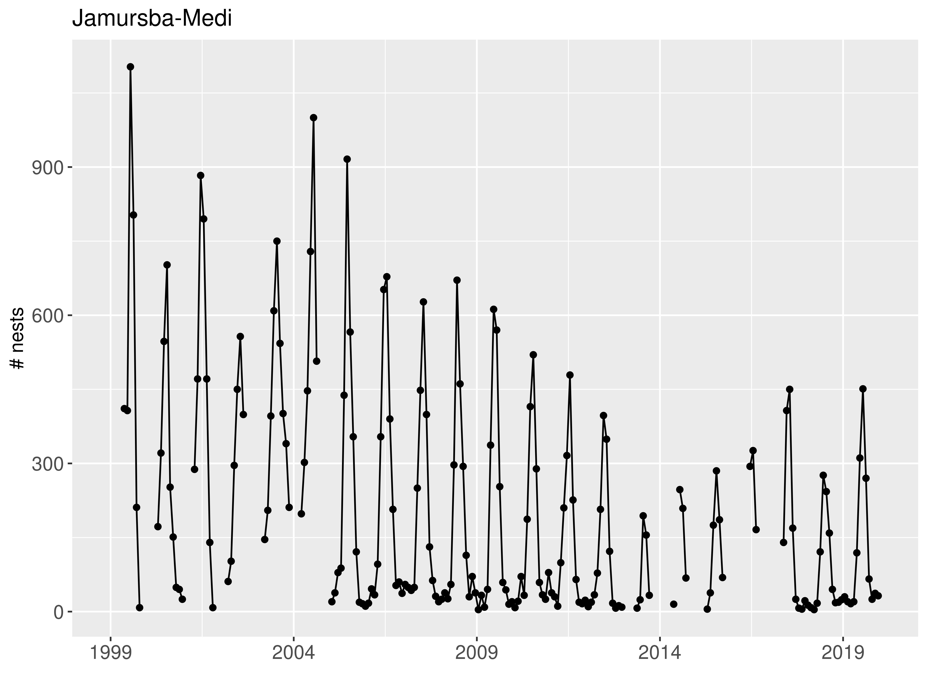

Figure 2. Nest counts at Jamursba-Medi since 1999

When the number of nests is plotted by month, the seasonal fluctations become more obvious (Figure 3). In general, high counts within a year are seen during summer months (approximately from April to September), whereas low counts are found during winter months (October through March).

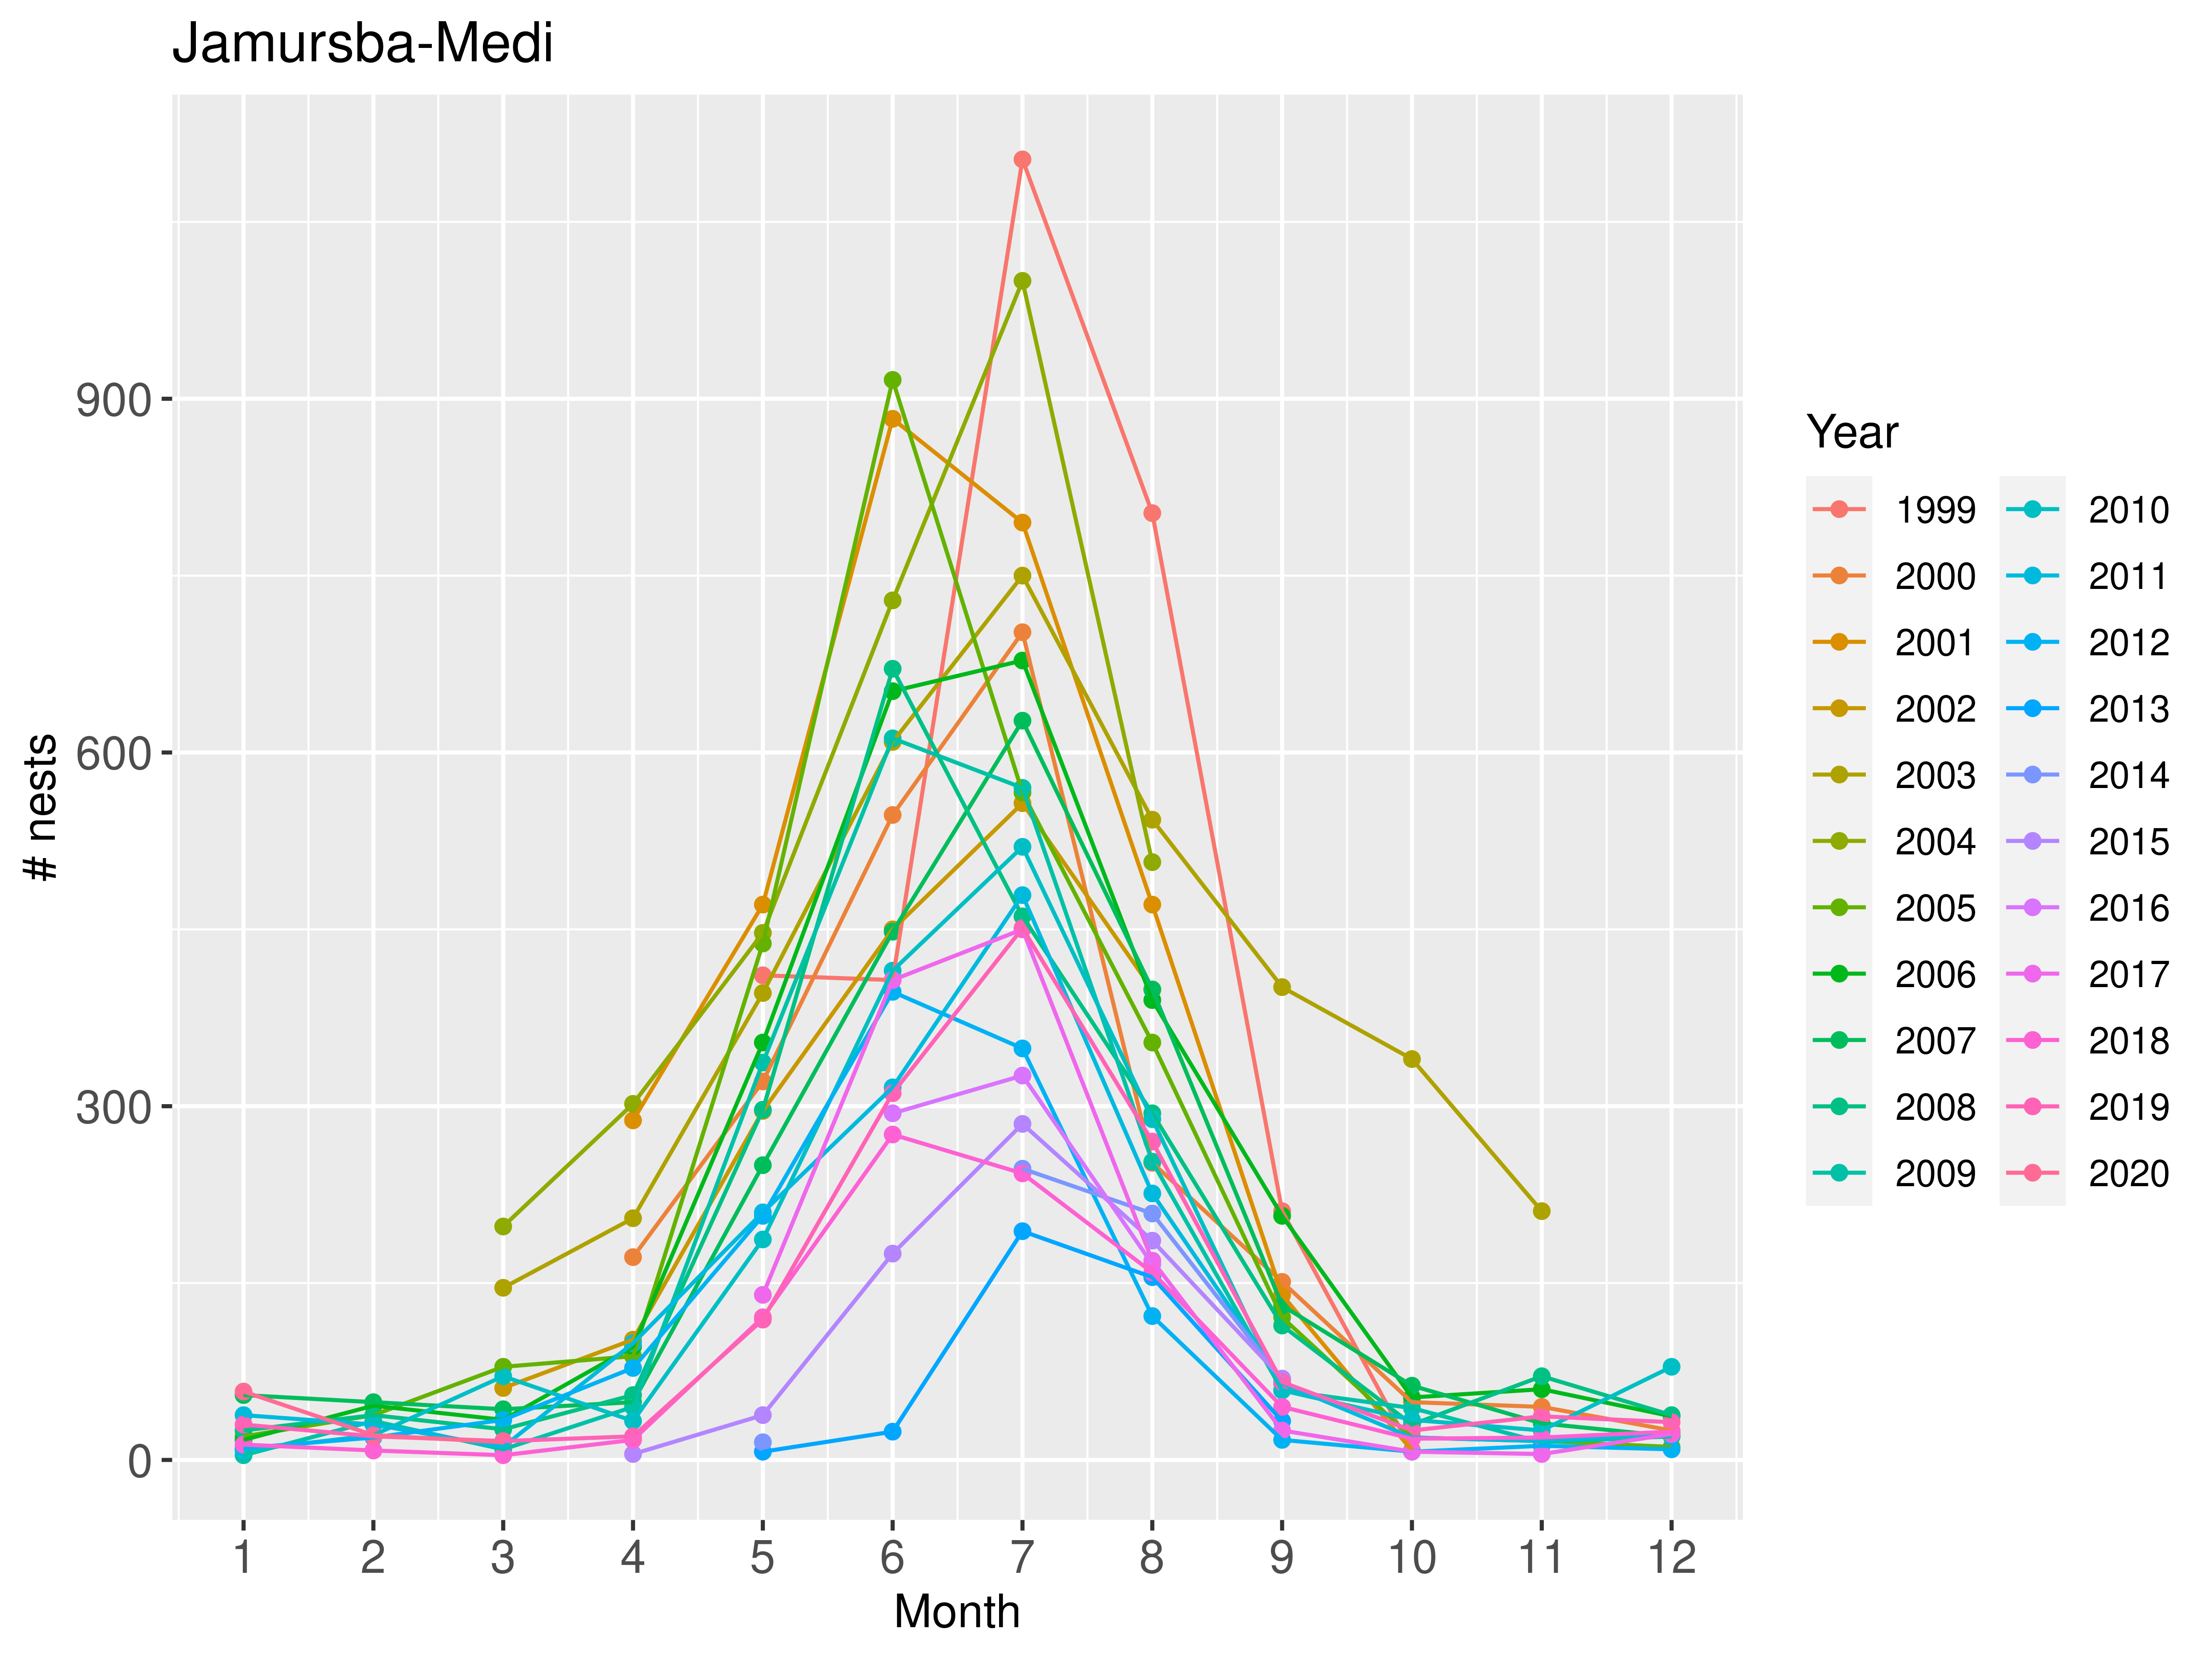

Figure 3. Monthly nest counts at Jamursba-Medi

### Wermon

At Wermon, some data have been collected since 2002. However, no data were collected between July 2013 and December 2015. The largest nest count was 1797 in 2002 (Figure 4).

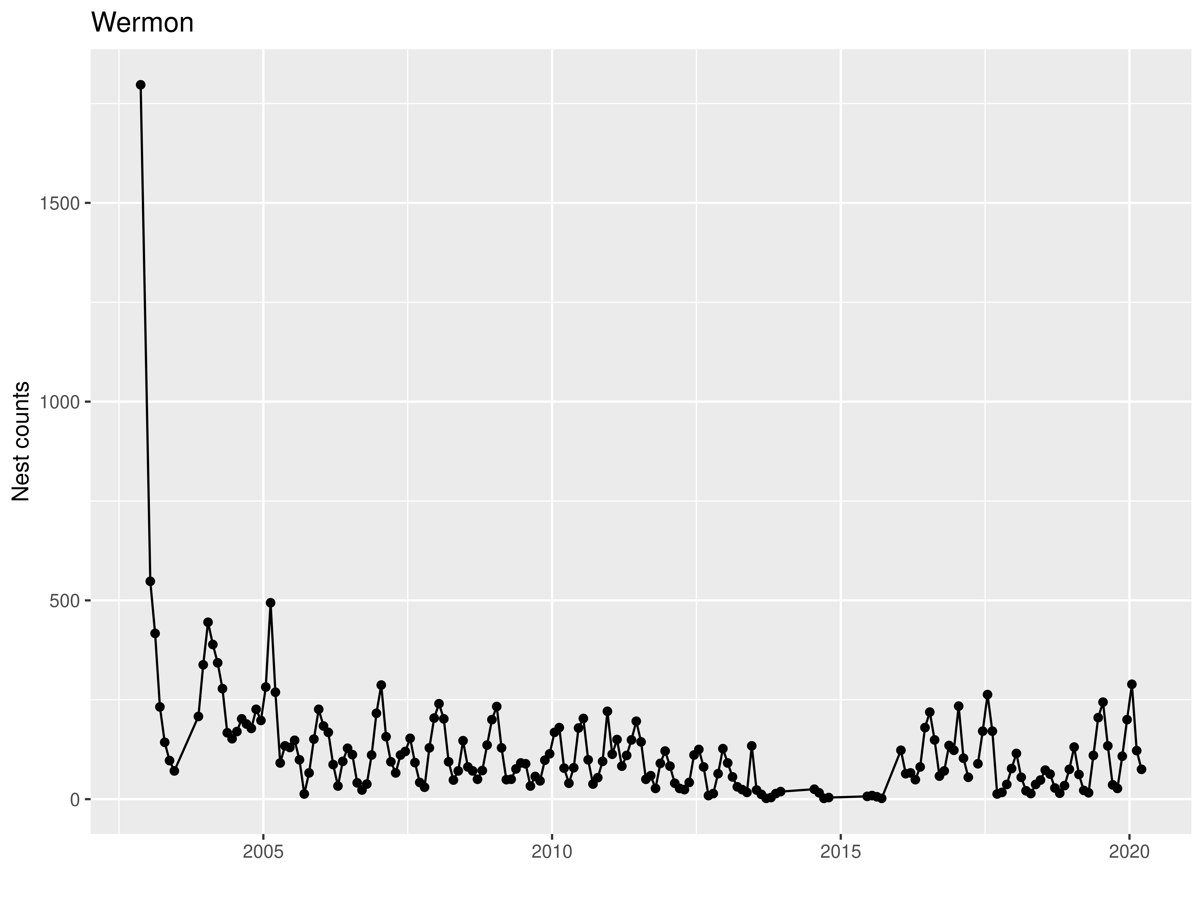

Figure 4. Nest counts at Wermon.

The temporal nest count pattern at Wermon is different from that of Jamursba-Medi (Figure 3 vs. Figure 5). At Wermon, there are two peaks annually: higher values are found between May and September and between October and April.

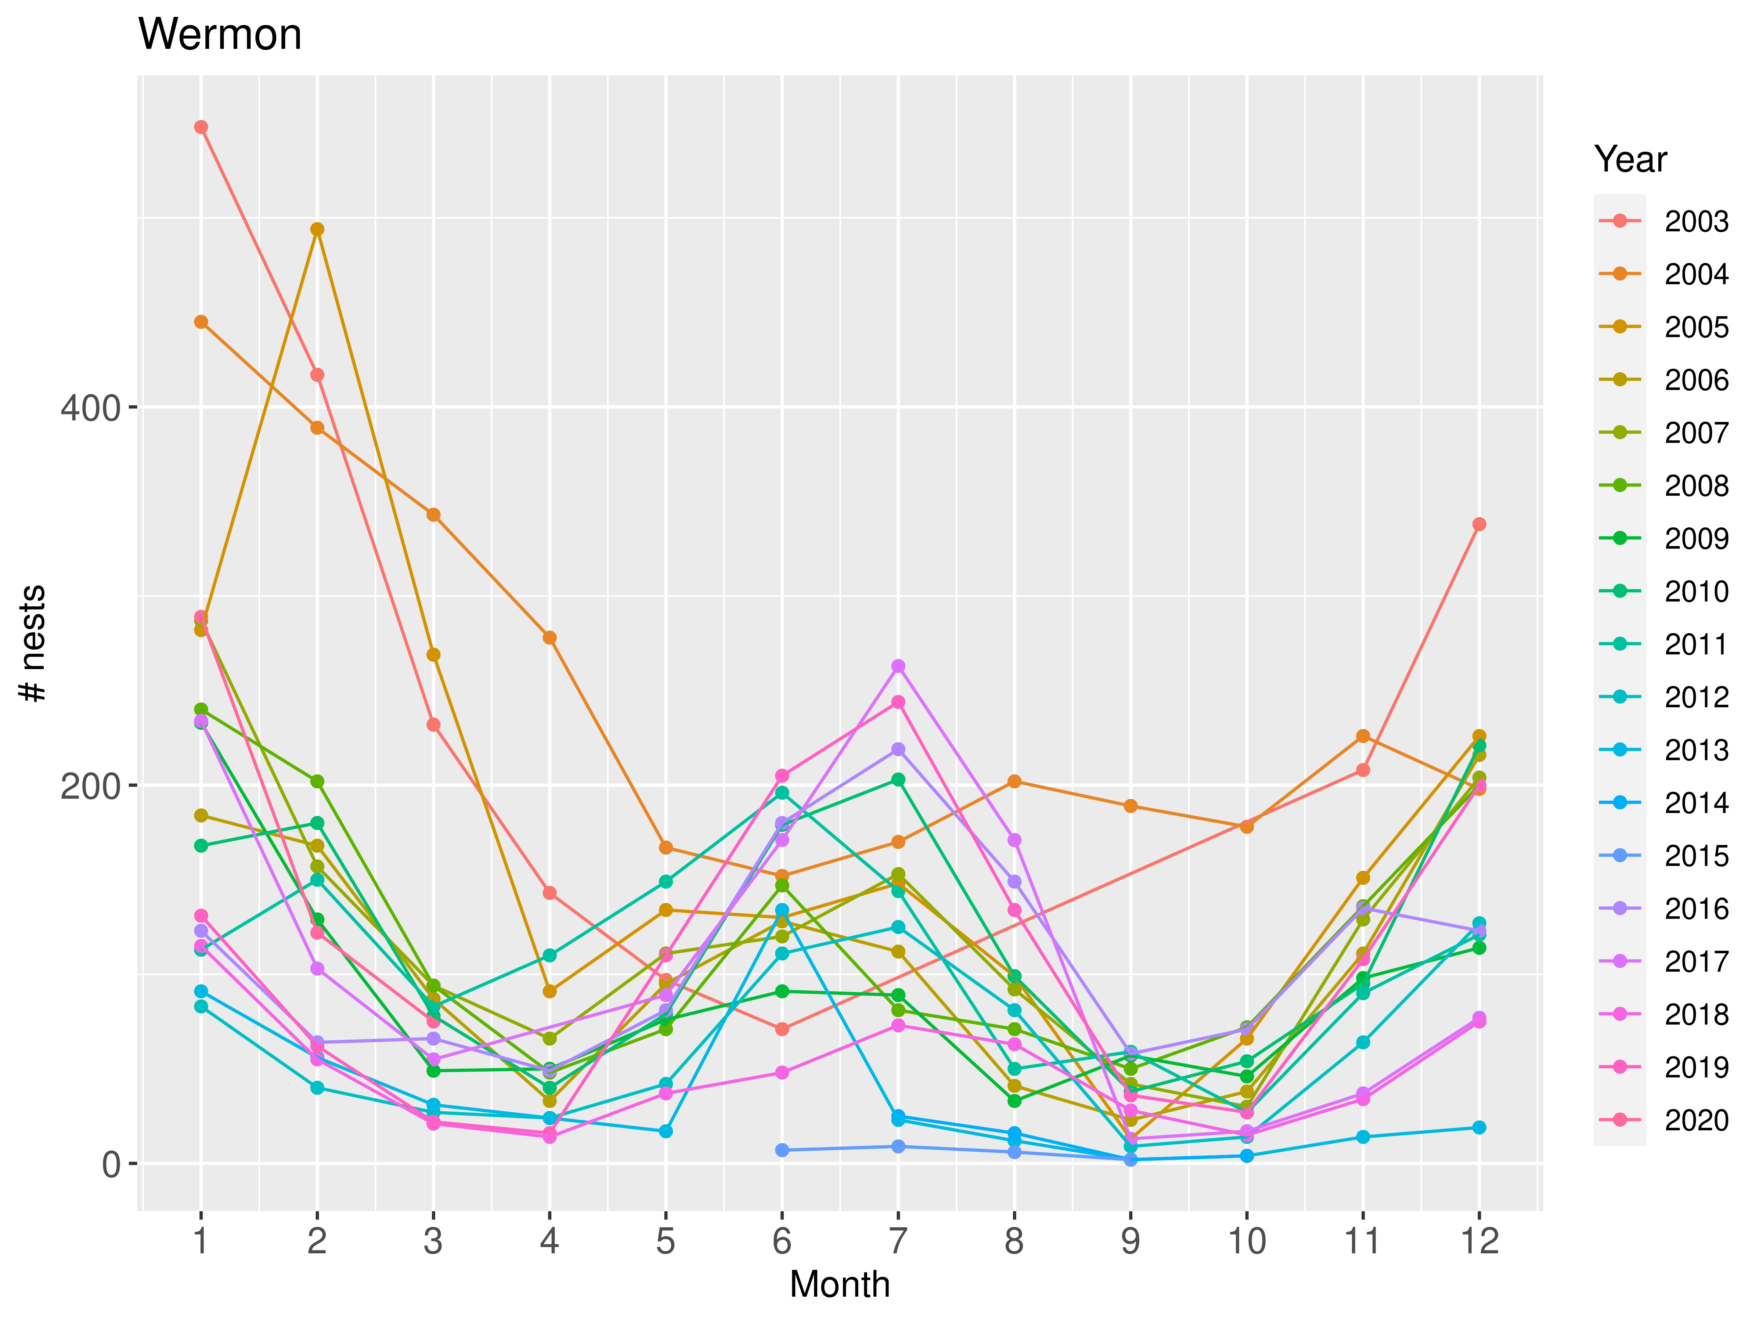

Figure 5. Monthly nest counts at Wermon. A large large count (>1500) was removed.

Observed counts for 2004 and 2005 seem to be outliers with respect to within-year patterns. Because this analysis used observed patterns to impute missing values, we removed these years from the data for the following analysis (Figure 6).

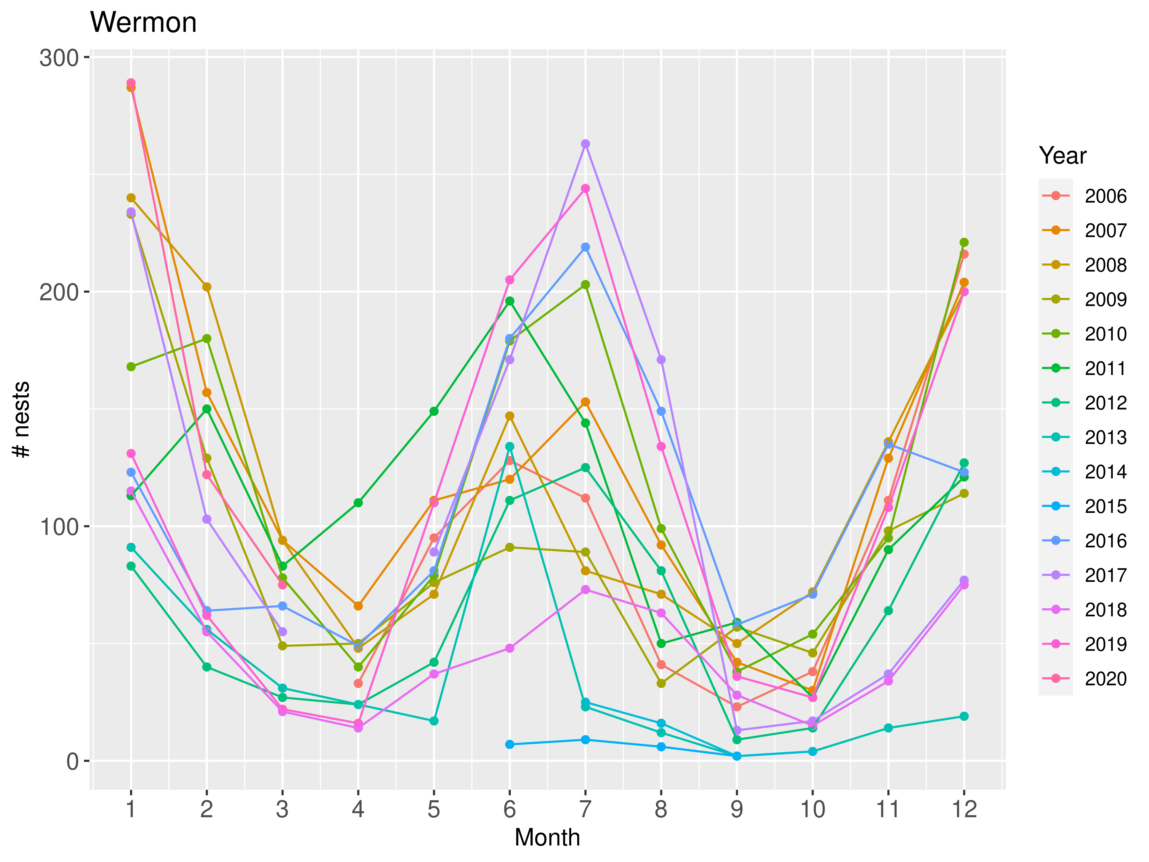

Figure 6. Monthly nest counts at Wermon. A large count (>1500) and counts for 2003 and 2004 were removed.

The two datasets (counts since 1999 for Jamursba-Medi and since 2006 for Wermon) were used in the following analysis for estimating missing counts.

### Complete Dataset

According to Pareto k diagnostic statistics, Model set 2 (annual nest abundance as a random variable) was better than Model set 1 (annual nest abundance as a non-random variable; Supplementary material). Among the 16 models within Moldel Set 2, the lowest LOOIC value was found for the model with Student’s t distribution for abundance (N) with location specific variance (Qs), Student’s t distribution for observations (y), and location-specific growth parameter (U). Gelman-Rubin Rhat statistics indicated successful convergence of all parameters (maximum Rhat = 1). We use the joint posterior distribution from this model for the inference.

Table 1. A comparison of models that were fit to the complete dataset and passed the goodness-of-fit test using Pareto k statistics.

|  |  |
| --- | --- |
| model | delta.looic |
| t_t_trend_DFS_v2_2U_2Q | 0.00 |
| t_t_trend_DFS_v2_1U_2Q | 0.04 |
| norm_t_trend_DFS_v2_1U_2Q | 0.13 |
| norm_t_trend_DFS_v2_2U_2Q | 0.14 |
| norm_norm_trend_DFS_v2_1U_2Q | 1.62 |
| t_norm_trend_DFS_v2_1U_2Q | 1.67 |
| norm_norm_trend_DFS_v2_2U_2Q | 1.71 |
| t_norm_trend_DFS_v2_2U_2Q | 1.93 |
| t_t_trend_DFS_v2_1U_1Q | 6.84 |
| t_t_trend_DFS_v2_2U_1Q | 7.03 |
| norm_t_trend_DFS_v2_2U_1Q | 7.47 |
| norm_t_trend_DFS_v2_1U_1Q | 7.55 |
| t_norm_trend_DFS_v2_1U_1Q | 8.52 |
| t_norm_trend_DFS_v2_2U_1Q | 8.95 |
| norm_norm_trend_DFS_v2_1U_1Q | 9.14 |
| norm_norm_trend_DFS_v2_2U_1Q | 9.26 |

The estimated mean growth rates at two beaches were -0.071 (SE = 0.062, p(U < 0.0) = 0.89) for Jamursba Medi and -0.013 (SE = 0.23, p(U < 0.0) = 0.52) for Wermon (Figure 7).

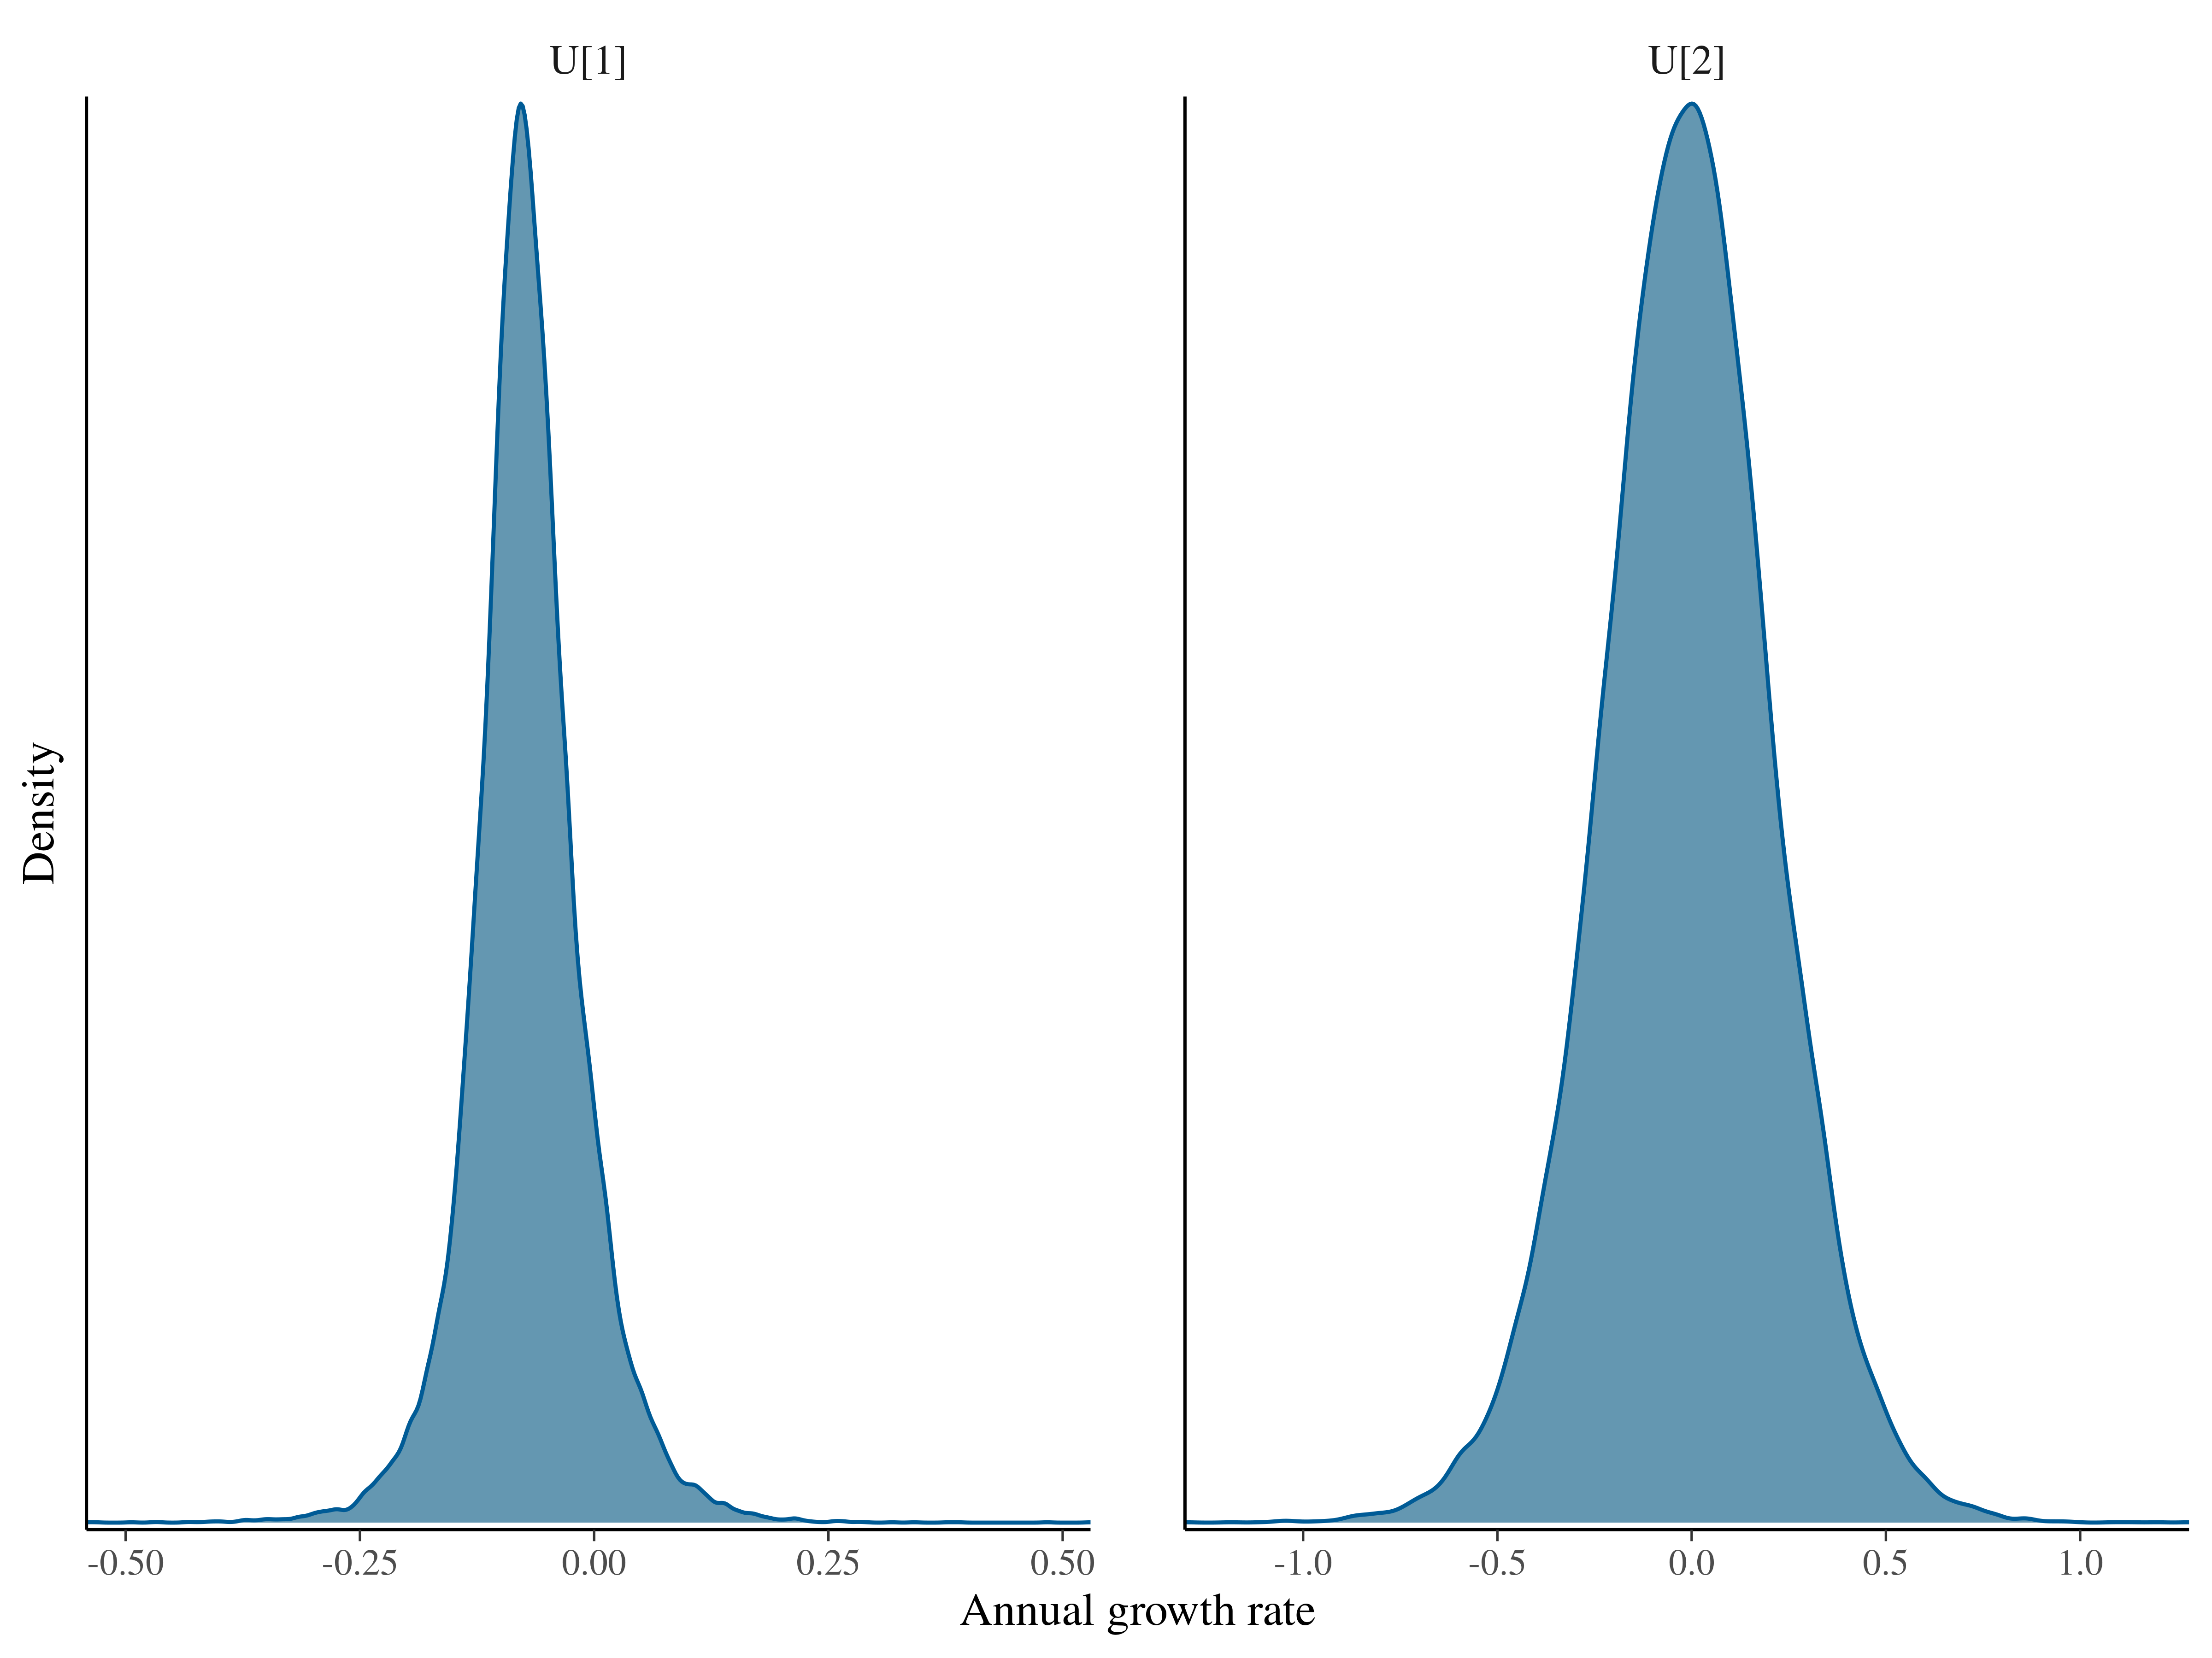

Figure 7. The posteior distributions of the geometric growth rates for Jamursba Medi (U[1]) and Wermon (U[2]) when the complete dataset was used.

### Summer dataset

As it was the case with the complete dataset, Model Set 2 (annual nest abundance as a random variable) fit better than Model set 1 (annual nest abundance as a non-random variable; Supplementary material) according to the Pareto k statistics. Among the 16 models within Model Set 2, the lowest LOOIC value was found for the model with Student’s t distribution for abundance (N) with location specific variance (Qs), Student’s t distribution for observations (y), and a common growth parameter (U) between the two locations. The second best model (LOOIC = 0.3) was the same model with location specific growth parameters (Table 2). Gelman-Rubin Rhat statistics indicated successful convergence of all parameters (maximum Rhat = 1 and 1). We use the joint posterior distributions from these two models for the inference.

Table 2. A comparison of models that were fit to the summer dataset and passed the goodness-of-fit test using Pareto k statistics.

|  |  |
| --- | --- |
| model | delta.looic |
| summer_t_t_trend_DFS_v2_1U_2Q | 0.00 |
| summer_t_t_trend_DFS_v2_2U_2Q | 0.31 |
| summer_norm_t_trend_DFS_v2_2U_2Q | 0.68 |
| summer_norm_t_trend_DFS_v2_1U_2Q | 0.96 |
| summer_t_norm_trend_DFS_v2_2U_2Q | 9.32 |
| summer_t_norm_trend_DFS_v2_1U_2Q | 9.34 |
| summer_norm_norm_trend_DFS_v2_2U_2Q | 9.41 |
| summer_norm_norm_trend_DFS_v2_1U_2Q | 10.05 |
| summer_t_t_trend_DFS_v2_2U_1Q | 11.26 |
| summer_t_t_trend_DFS_v2_1U_1Q | 11.73 |
| summer_norm_t_trend_DFS_v2_2U_1Q | 14.34 |
| summer_norm_t_trend_DFS_v2_1U_1Q | 14.91 |
| summer_t_norm_trend_DFS_v2_2U_1Q | 16.12 |
| summer_t_norm_trend_DFS_v2_1U_1Q | 16.31 |
| summer_norm_norm_trend_DFS_v2_2U_1Q | 18.81 |
| summer_norm_norm_trend_DFS_v2_1U_1Q | 19.47 |

For the one growth rate model, the estimated mean growth rates at two beaches were -0.06 (SE = 0.062, p(U < 0.0) = 0.85, Figure 8)

For the two growth rate model, the estimated mean growth rates at two beaches were -0.063 (SE = 0.066, p(U < 0.0) = 0.85) for Jamursba Medi and -0.0057 (SE = 0.28, p(U < 0.0) = 0.51) for Wermon (Figure 9).

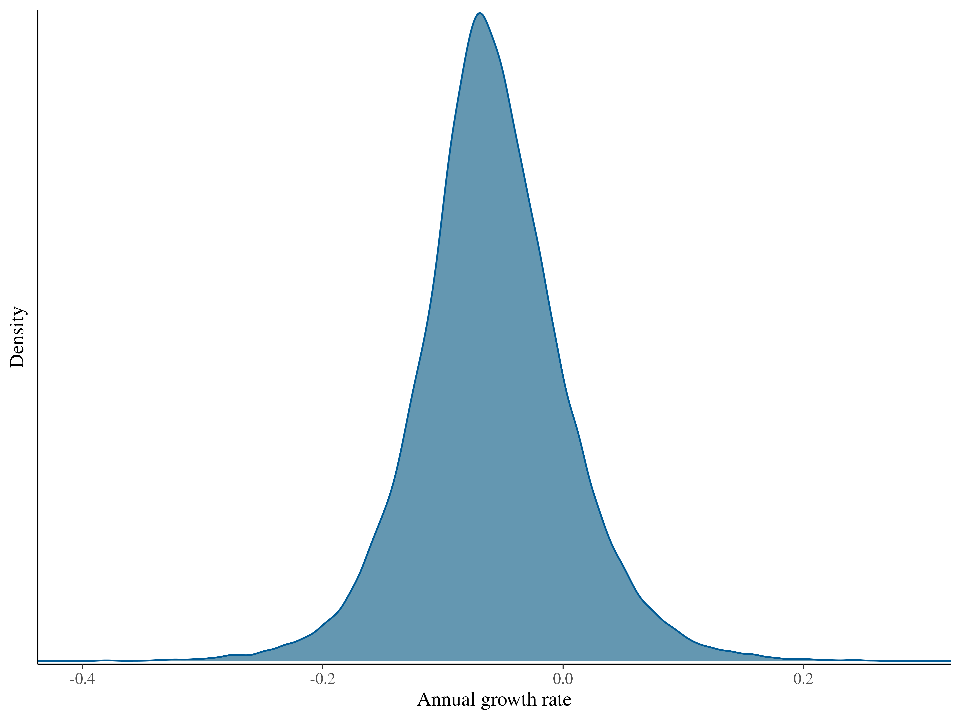

Figure 8. The posteior distribution of the geometric growth rate when the summer dataset was used.

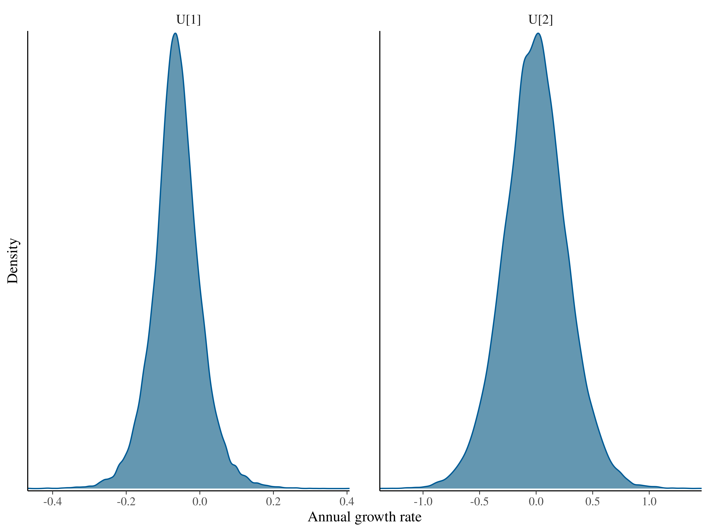

Figure 9. The posteior distributions of the geometric growth rates (U[1] = Jamursba Medi and U[2] = Wermon) when the summer dataset was used.

### Winter dataset

Among the 16 models fit to the winter dataset, only one model was found appropriate based on the Pareto k statistic (Model Set 2 with Student’s t distribution for abundance (N) with a common variance (Q), and Student’s t distribution for observations (y). Gelman-Rubin Rhat statistics indicated successful convergence of all parameters (maximum Rhat = 1.0006). We use the joint posterior distributions from this model for the inference.

The estimated mean growth rate at Wermon -0.021 (SE = 0.26, p(U < 0.0) = 0.53, Figure 10)

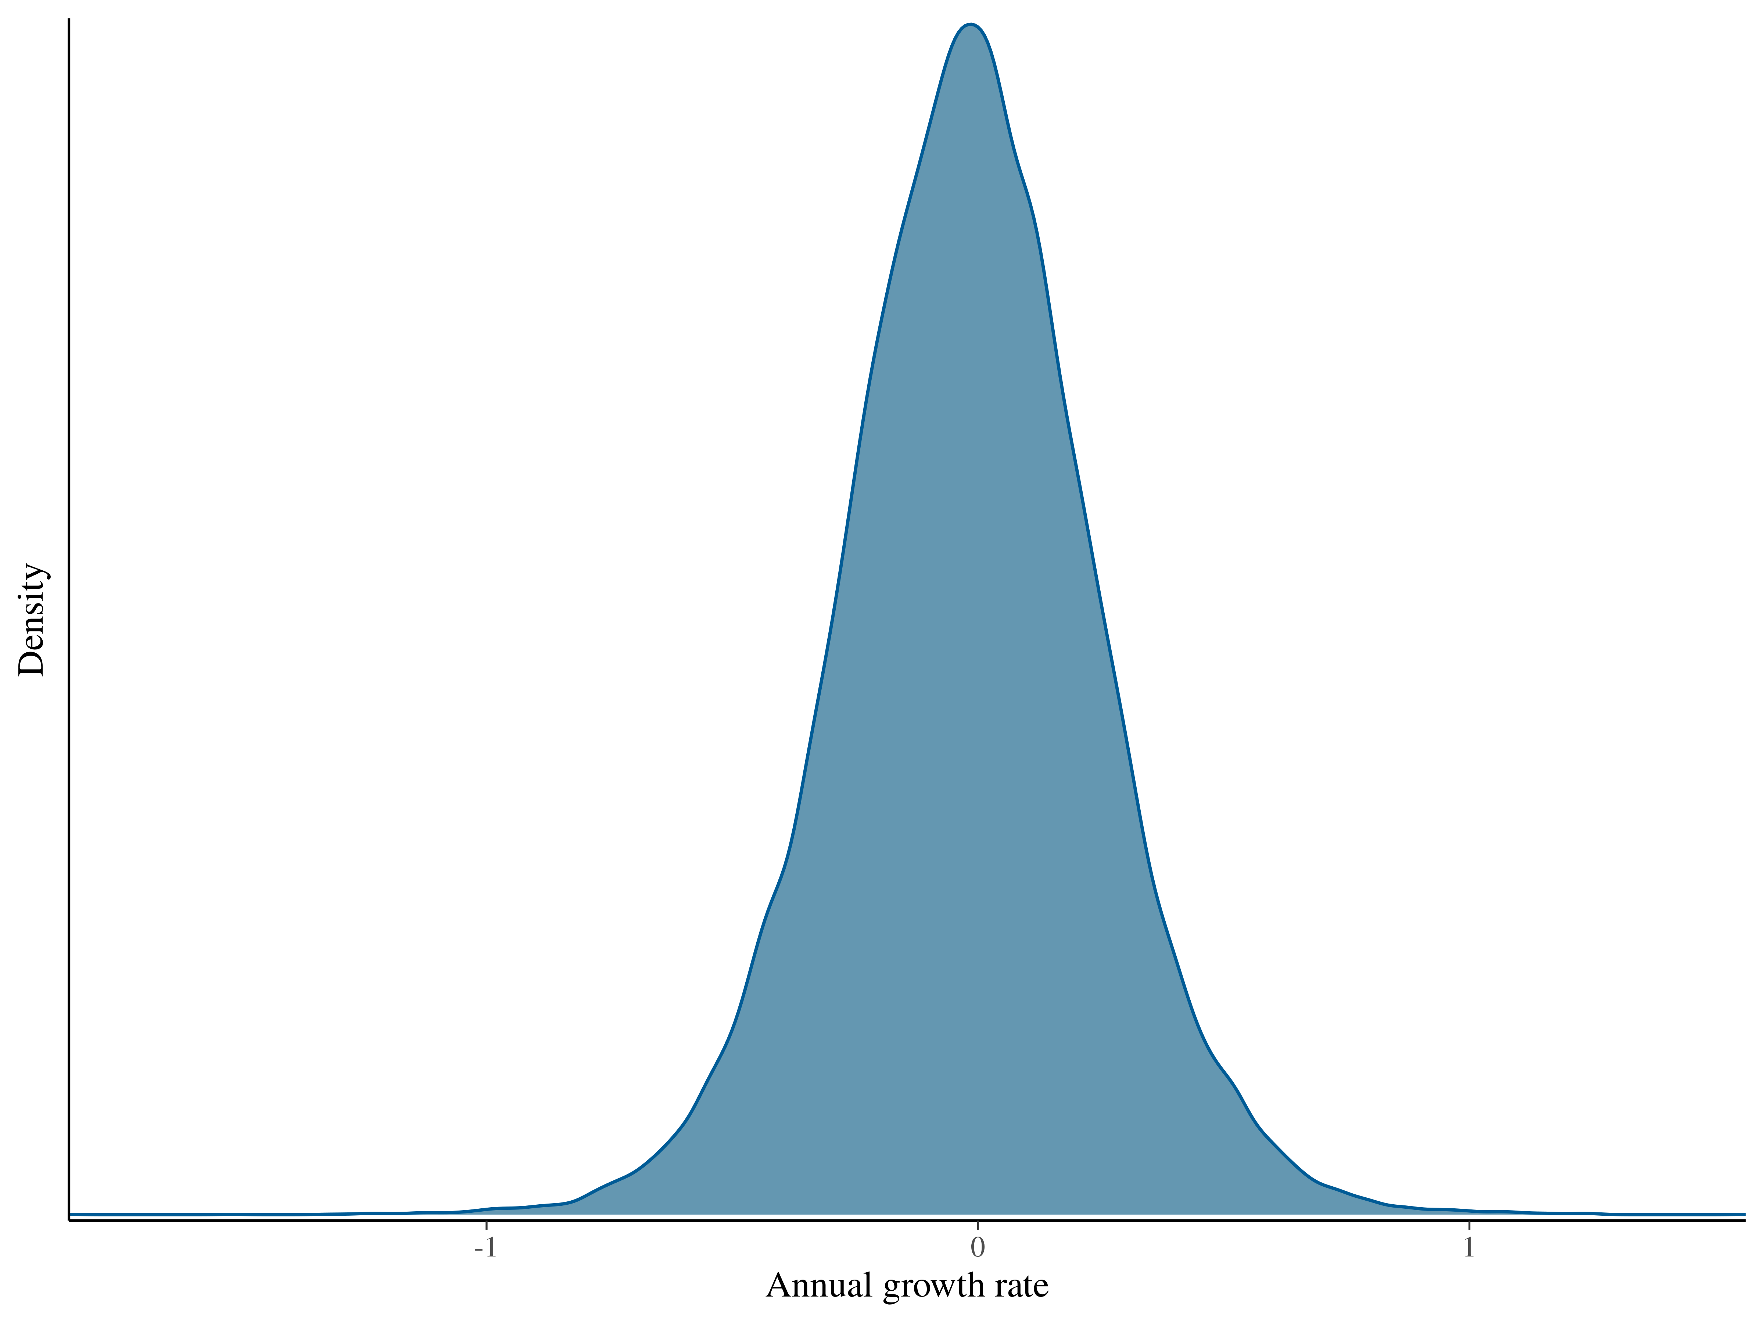

Figure 10. The posteior distribution of the geometric growth rate when the winter dataset was used.

# Appendix

## Observed and imputed (with 95% CI) data

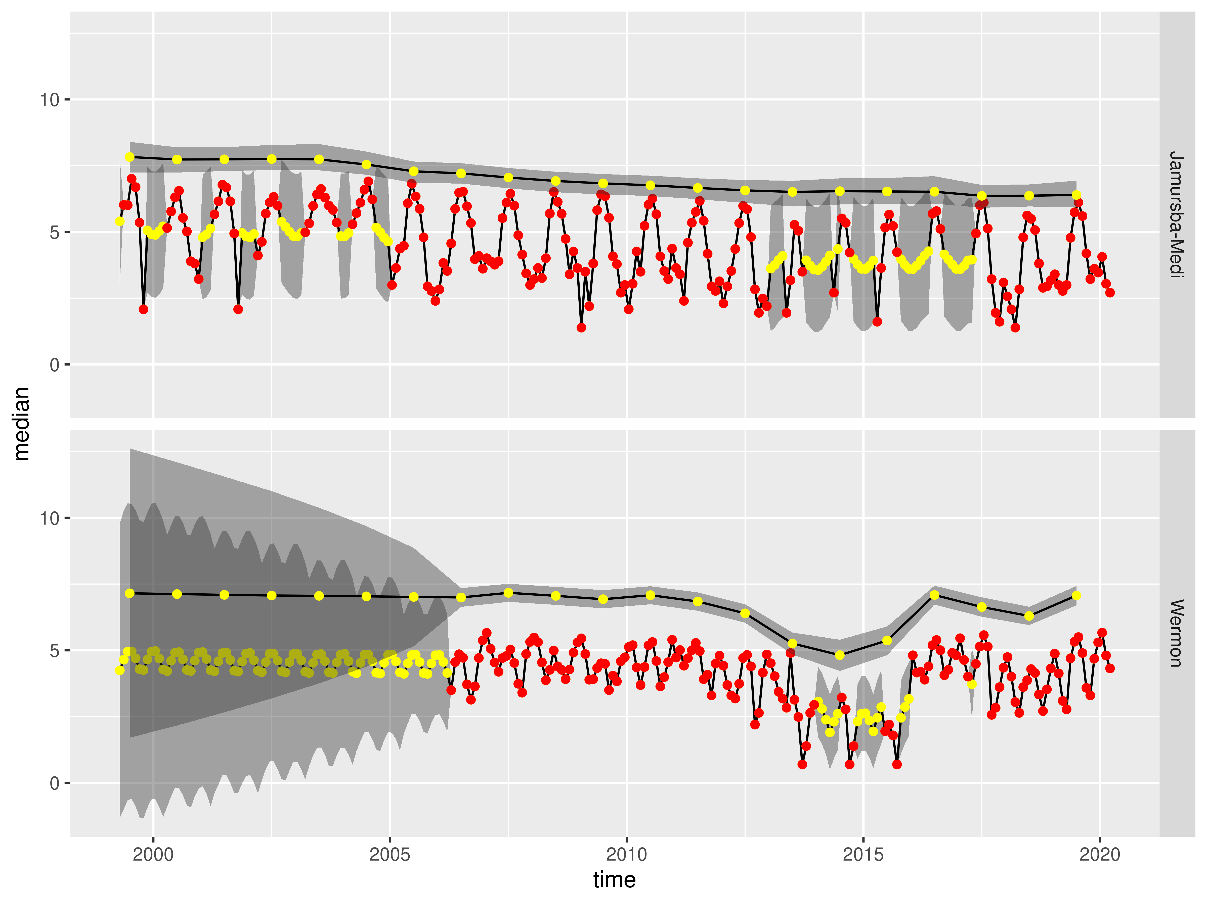

Figure A1. Observed and imputed (95% CI) when using the complete dataset.

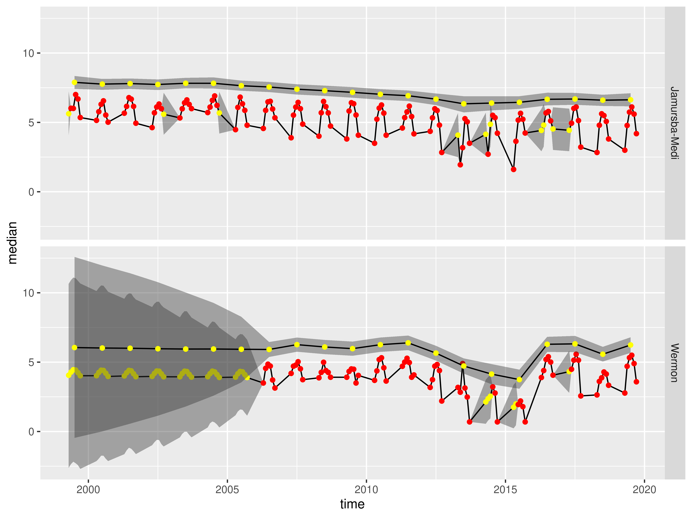

Figure A2. Observed and imputed (95% CI) when using the summer dataset.

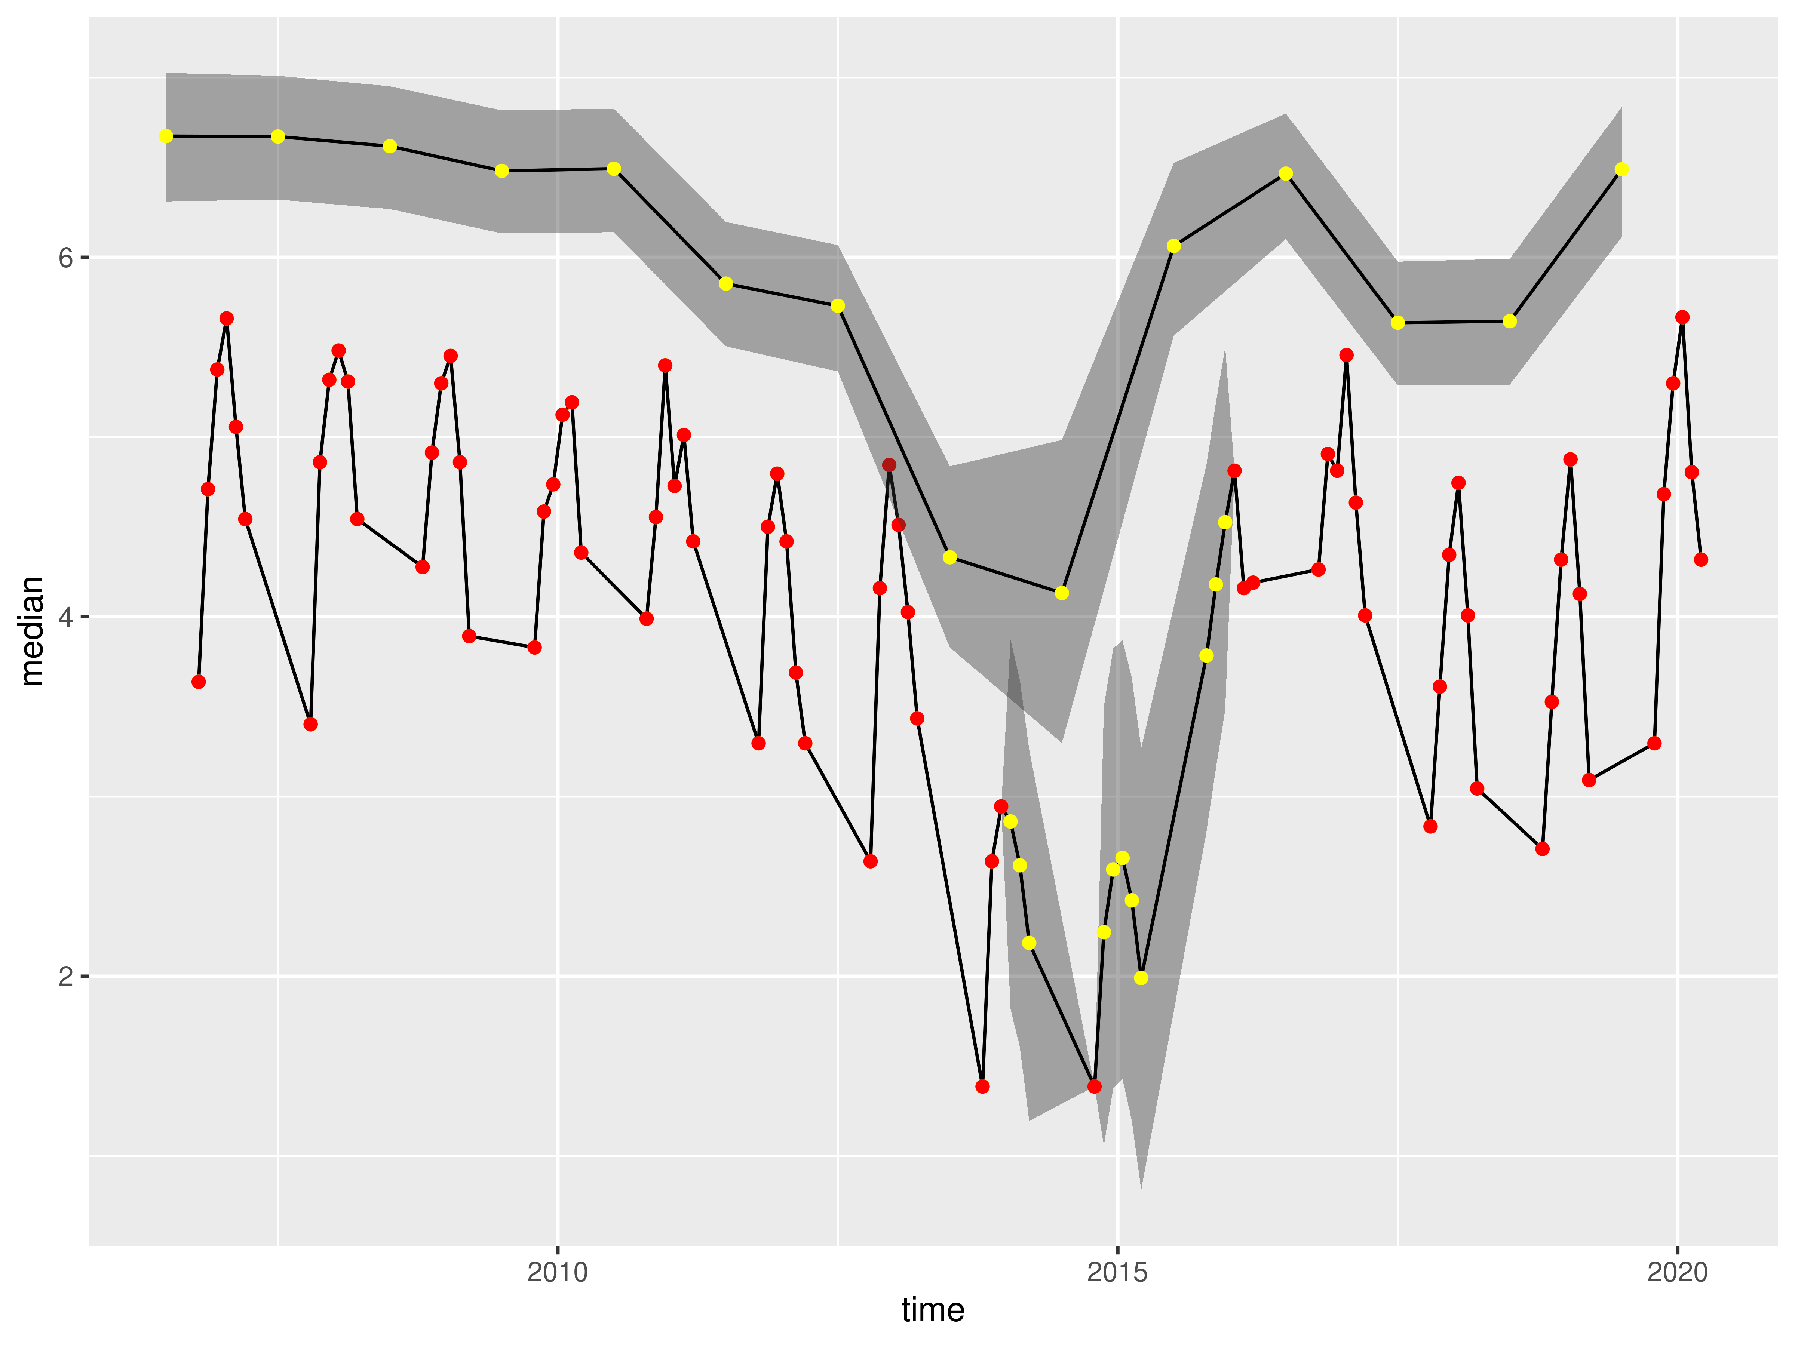

Figure A3. Observed and imputed (95% CI) when using the winter dataset.